Single Mode Stable emission.
As we have seen the width of the gain curve of a semiconductor laser is much broader in wavelength than the wavelength spacing between the semiconductor modes. This means that there is the potential for “multi-mode” emission where more than one wavelength that satisfies the cavity standing wave criterion can be satisfied.
Strictly the modes described above are so called longitudinal modes, or axial modes as they are along the axis of the laser. It is also possible to get “transverse modes” in the laser where reflections from slightly off-axis modes can also be stable in the cavity and lase. The mechanisms described below can help eliminate both multi-model behaviour types.

Distributed Feedback (DFB) Laser.
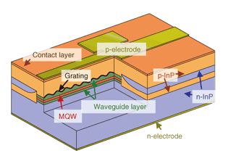
In the laser we currently have a waveguided stripe of material that we keep the optical mode and electrical gain confined in. Along the length of the stripe the material is essentially uniform, meaning of course the refractive index is uniform. In a DFB laser we modulate the refractive index along the length of the stripe, by etching shallow stripes into the material just above (or in principle below) the quantum well region. The quantum wells are smooth so the electrical gain remained unaltered, but the larger optical mode can “see” (or is affected by) the periodic changes in the refractive index of the material. These changes are designed to give enhanced reflection for the allowed mode. The wavelength range which gives in enhanced reflection is very small meaning the laser can give single mode emission.
Periodic changes in refractive index give a kind of Bragg grating. The more periods in general the narrower (in wavelength range) and more intense the allowed reflection can be.
To manufacture this device we can use a two or three stage growth process, with fabrication steps between each one to etch the desired structure – the Bragg grating and/or the lateral waveguiding. To make the device laser bars are cut (cleaved) as described before and a highly reflective coating is put on the back end cut surface, and an ant-reflection coating on the laser emitting end. The front mirror uses only the grating. A problem is that the cleave in the back grating may be anywhere in the grating period. Some positions give excellent propoerties, where others give poor performance, thus the fraction of devices that are usable can be reduced.

Cleaved Coupled Cavity Laser.
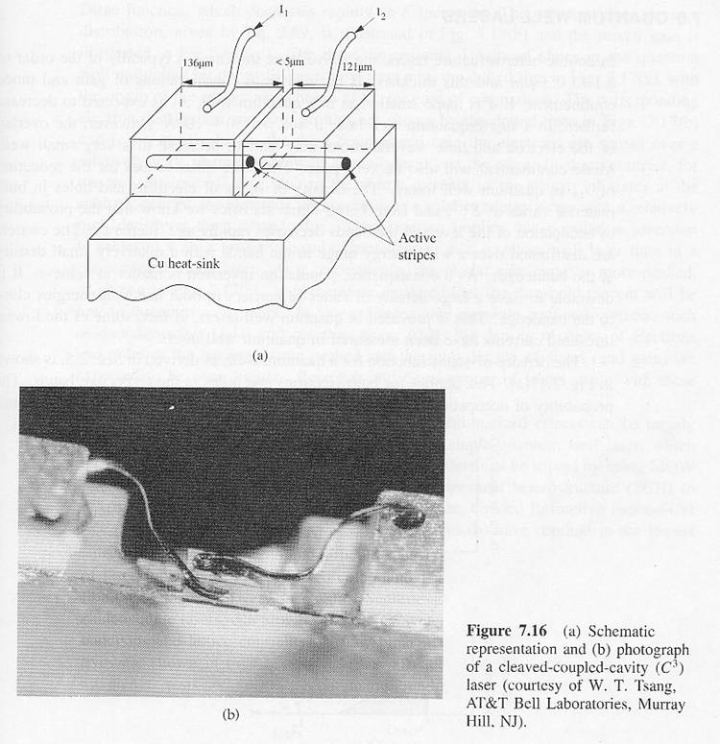
An alternative method to get single mode emission is to use a so called cleaved coupled cavity laser. In this case a slot is cut in the middle of the laser (somewhere, not necessarily the exact middle) to create effectively two lasers that are coupled together. For the laser operation the optical mode must satisfy the standing wave criterion in both parts which dramatically reduces the number of allowed modes. As a result stable single mode emission can be achieved.

Thermal Issues
Another issue for semiconductor lasers is so-called “mode-hopping”. To understand this we need to consider two effects that affect a semiconductor material’s optoelectronic properties as the temperature changes. The temperature may change because it is being driven harder (higher current density, more resistive losers, more heat) or because the ambient temperature of the device changes.
The two effects temperature has are on
- Refractive index
- The bandgap of the material.
In reality the refractive index tends to change slowly with temperature (increasing as T increases) while the bandgap changes more rapidly (decreasing). Let us consider what this means for a single mode of a semiconductor laser.
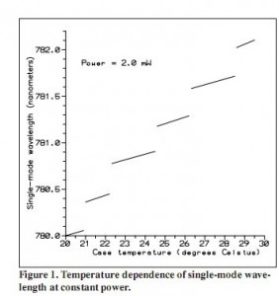
Keep in mind the standing wave criterion:
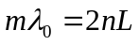
As the temperature increases the refractive index increases (the cavity length also will increase due to thermal expansion of the material but we will ignore this). This means that the optical path length of the cavity (equal to the product of length and refractive index) will increase slightly. As a result the wavelength of that particular mode must also increase slightly, giving a red shift to the laser peak. However, as the temperature increases so the bandgap decreases, and this is more rapid that the red shift due to the optical effect. Eventually the peak of the gain curve can move from one peak to the next allowed mode giving a sudden jump the the emission wavelength. This is called “mode-hopping”.

Laser Far Field Pattern
Lasers are famous for producing a “beam” of light in the form of a spot. This is an natural result that all the photons emitted by stimulated emission are as a result of light bouncing back and forth between the mirrors, and the fact that all the photons are identical, including in their direction of propagation. However, a semiconductor waveguide is of the order, or less that the wavelength of light in the material, and thus when the beam is emitted it diverges rapidly in the vertical direction. The physical width of the stripe is usually of the order of a few microns and thus the divergent in that direction is much reduced. As a result the laser beam is very ellipitically shaped and in many cases will need to be corrected with lenses, for example to be used to read an optical disk, or make a laser pointer. For fibre optic systems this divergence has implications for the amount of light that can be coupled to the fibre and methods to reduce the divergence are a key design issue.

The actual divergence can be treated mathematically by Gaussian optics, from which it can be shown that if the “beam waist” (which is the narrowest physical half-width the mode is confined to) is narrowed the divergence angle increases according to the relationship:
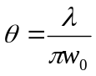where 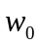 is the half width of the “waist” (assume the emitting edge of the laser)

This rule applies to all lasers and in some applications can be important. For example if one wants to bounce a laser off the moon (there are reflectors left from Apollo missions for this purpose as it allows a precise determination of the distance between the Earth and moon) then the laser beam is artificially expanded then focused to infinity to give the lowest possible divergence over the long distance. If one is using a laser for precise optical alignment then this is what will ultimately determine the resolution of the system.

Vertical Cavity Surface Emitting Laser (VCSELs)
Edge emitting lasers can be easy to manufacture, but they suffer from a number of disadvantages.
First is the multimode behaviour of the device, requiring methods to eliminate this in many cases,
Second the far field pattern is not circular but elliptical requiring special lenses to focus it
Third its manufacture is crictically dependent on the quality cleaves made, which mean that the final device test can only be taken after the device is fully processed. One cannot use on wafer probing to determine if the device is in spec or not.
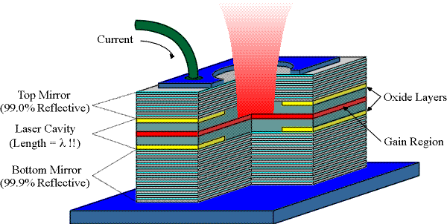
These issues could be overcome if we can use a surface emitting laser. However in the vertical direction the material is at best a few microns thick, as opposed to hundreds of microns in a stripe laser. This means we must either get a very high gain per unit length, or have very high mirror reflectivities to compensate. In practice the key first issue is to get a highly reflective mirror.
The high reflectivity mirror is created usually using AlGaAs (with high Al composition) and GaAs layers grown alternatively. Each layer is designed to be a quarter of the wavelength of the laser light thick (taking into account the refractive index). As there is a reasonable good refractive index difference (or refractive index contrast) between AlGaAs and GaAs using many periods we can get reflectivities well in excess of 99%. As both are semiconductors current can be driven through the multiple layer structure to the active region. The larger the number of periods the higher the peak reflectivity can be, although eventually absorption in the layers limits the maxium achieveable value.
The active region is very short usually between half a wavelength and three times the wavelength of the laser light long (again taking into account the refractive index in the material (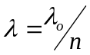)).
However gain can only occur in the quantum wells that are in the cavity. These have to be positioned critically to occur where the interation with the optical mode is at a maximum, at the anti nodes of the standing wave in the cavity.
VCSELs have the advantage that they can emit circular beams with relatively low divergence and that they can be tested on wafer reducing the cost. They are very difficult to grow as the mirrors must have their peak reflective wavelength at the same wavelength as the cavity mode, which must be at the same wavelength as the emitting energy of the quantum wells. As the cavity is so short (at most a few wavelengths) the spacing between the allowed optical modes is hugh so single more operation is dominant. The emission wavelength is much more stable with temperature.
Their disadvantages are that despite the better beam shape it is harder to attach a single mode fibre accurately to a top surface. Also the maxium power they can produce is limited to a few mW at best.

